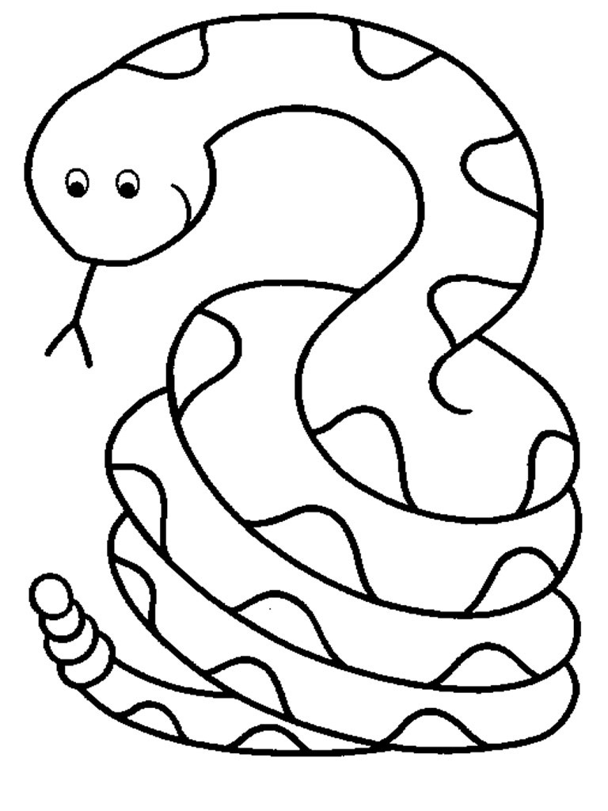

**I** – green **the** – blue **go** – red **no** - pink

I

the

go

no

no

no

no

no

no

no

no

go

go

go

go

go

the

the

the

the

the

I

I

I

I

I

I

I

I

I

I

I

I

I