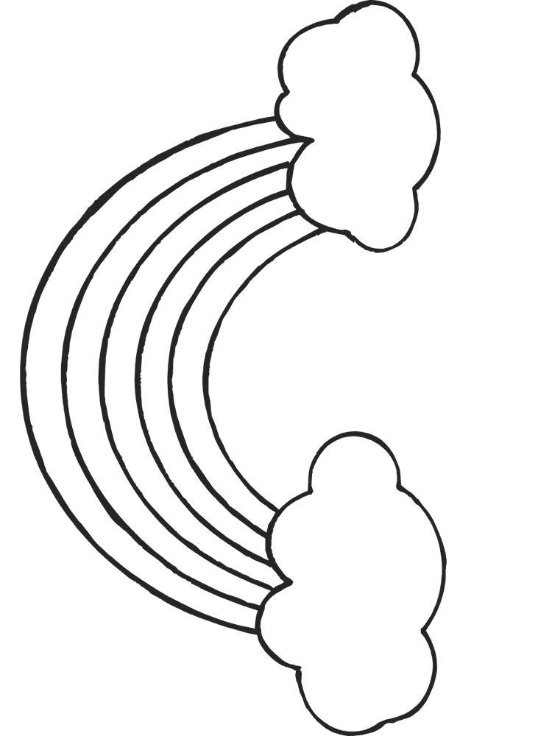

my

all

all

we

you

you

you

you

her

her

my

my

they

they

we

we

**we** – red

**all** – orange

**they** – yellow

**my** – green

**her** – pink

**you** - blue