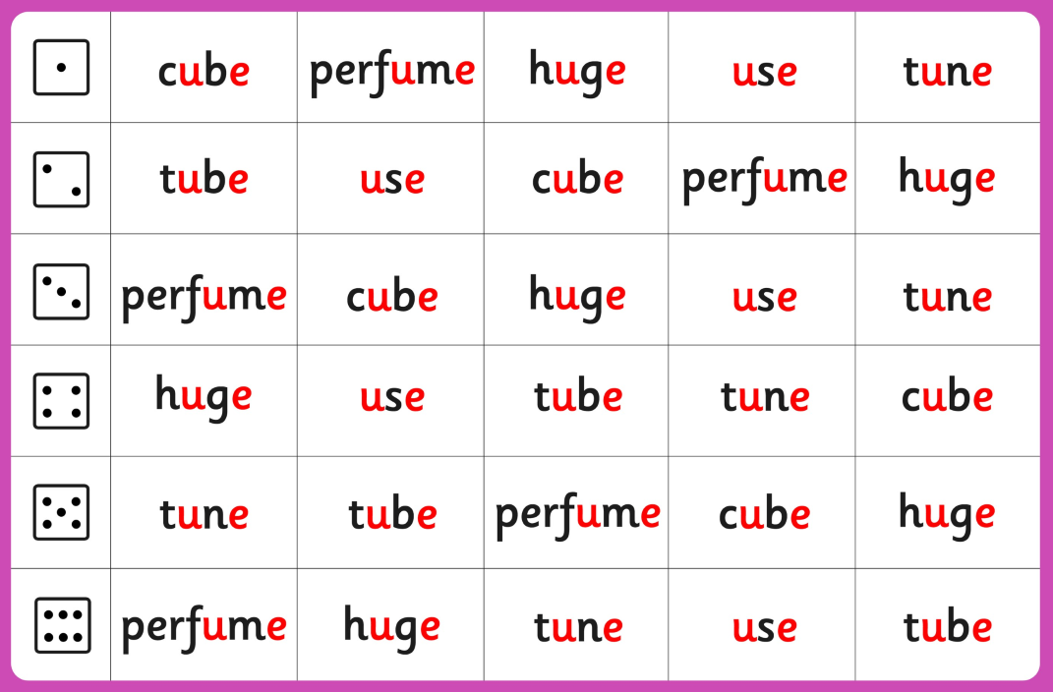

**scream**

**straig**

**three**

**sproo**

**splef**



**splash**

**scrape**

**strong**

**scream**

**sploot**

**scream**

**strund**

**scruz**

**screen**

**scrap**

**streak**

**thrat**

**scrape**

**sprand**

**spring**

**spray**

**thrim**

**sprain**

**stroim**

**spleep**

**splat**

**splort**

**sploft**

**string**

**screp**

**street**

Start