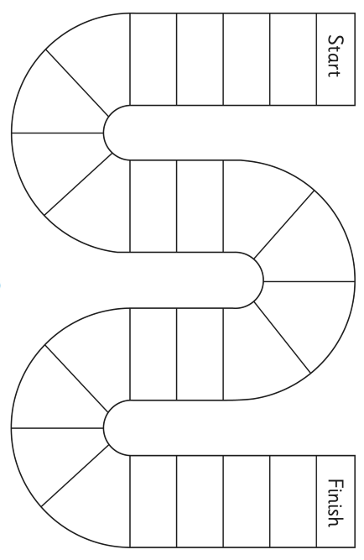

Finish

Phase 3/4

crown

weeks

moid

look

florm

part

quop

sting

turn

hair

beard

tain

bright

boil

theed

now

chip

wish

Go back 2 spaces!

Go back 4 spaces!

Go back 3 spaces!

top

sat

mip

Start



Finish

Phase 3-5

zoy

scoad

mawk

launch

shine

level

cupcake

puef

phones

stones

streap

veak

glue

scrape

toes

grow

cube

pebe

chomp

string

shook

elp

Go back 2 spaces!

Go back 3 spaces!

Go back 4 spaces!

Start



Finish

Phase 3-5

blayp

plaster

foe

goals

thrume

barks

zuep

shawl

august

season

freve

chime

cones

cabe

shrimp

haul

bead

plug

koo

aft

Go back 2 spaces!

Go back 3 spaces!

Go back 4 spaces!

below

Start



Finish

Phase 3-5

throwing

nephew

blaum

burns

might

stoe

pies

argue

blue

stoat

crube

igloo

escape

extreme

flope

splash

paw

stripe

flood

Go back 2 spaces!

vea

esp

Start

Go back 4 spaces!

Go back 3 spaces!



Finish

Phase 3-5

bime

scrone

pame

tephew

choap

sceve

Start

saucers

thawz

haunt

groups

rules

forever

complete

stick

Go back 4 spaces!

Go back 3 spaces!

Go back 2 spaces!

clouds

flew

street

scroop

boils

shin

ept