Painting helps me to develop my creativity. Sometimes I accidentally get paint on my clothes as I work.

I am learning to try new healthy snacks. I tried hard to peel my own orange.

I am trying so hard to write my name. I have been busy practising mark making with the pens.

Sometimes my uniform comes home a little wet. I learn huge amounts of science and maths when I play in the water tray!

The Mud Kitchen is very messy but it helps me to develop my imagination and use of descriptive language.

I love to be outside! Big movements like running and jumping help me to get better with small movements like writing!

I’m sorry that my clothes got dirty today, but it helps to show what I have been learning!

It’s not dirt …

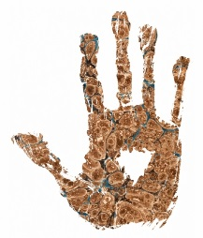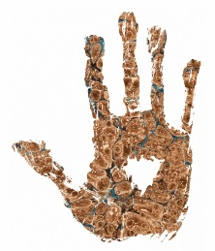It’s learning!

[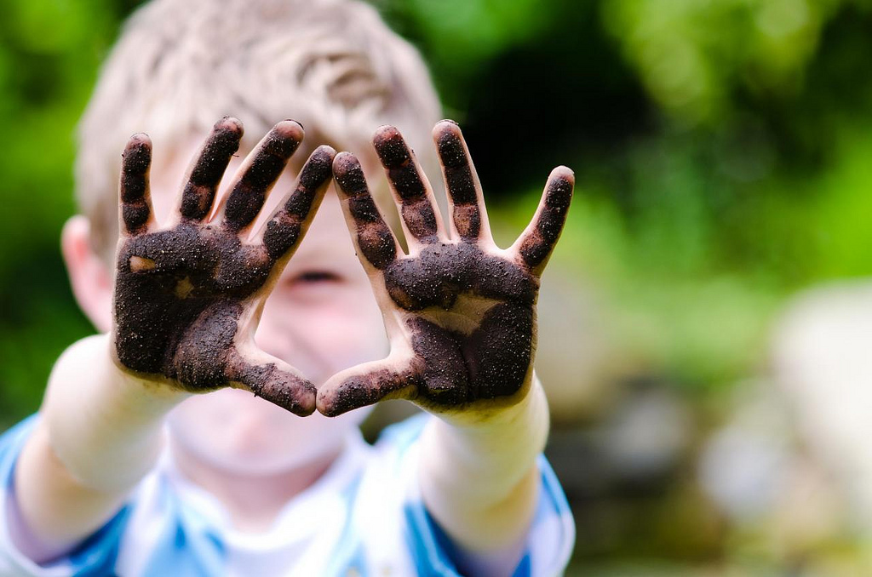](https://www.google.com/url?sa=i&rct=j&q=&esrc=s&source=images&cd=&cad=rja&uact=8&ved=0ahUKEwiIz9Hxt_rOAhVMthQKHYfJB1QQjRwIBw&url=https://www.flickr.com/photos/peeandcat/7585648838&bvm=bv.131783435,d.ZGg&psig=AFQjCNErsK2QXOpmt7WpEvsJZUBIwoYkOA&ust=1473240769498859)