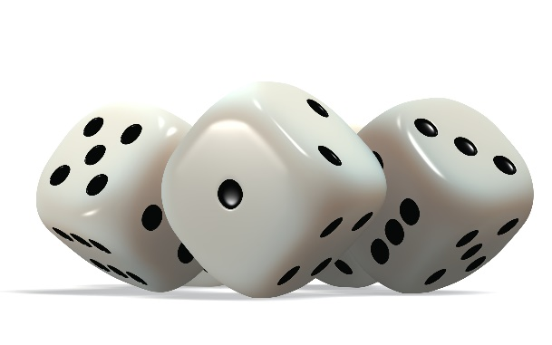

One more:

Number rolled:

One less:

Build it:

Write it: